Instruction for mobile monitor

Remark: only the mobile phone with Windows Mobile and Symbian operating system can support the mobile phone monitor function.

1. DVR Setup

Please login MAIN MENU>>>>> ADVANCE>>>>>MOBILE, setup as follow:
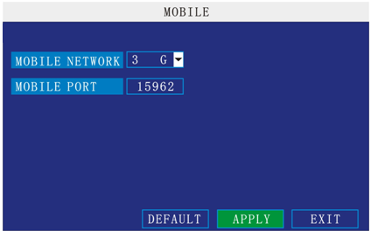

Mobile Network: Please select the network your SIM card support.
Mobile port: this port should be open in the router; otherwise you can’t see the live view in mobile phone.
Remark: this port can’t be the same with any other port and different DVR should have different sever port.

- Mobile phone setup
  - Windows Mobile Operating system
1）Program download
Please copy the installation program whose name is amplayersetup.CAB from the attached CD to your mobile phone, the default save path is My Documents.
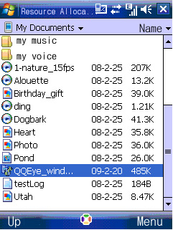

2）Click the program and start to install it, just select default path when it ask you to select install path.
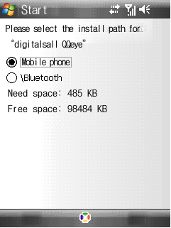

3）Click install button to start to install.
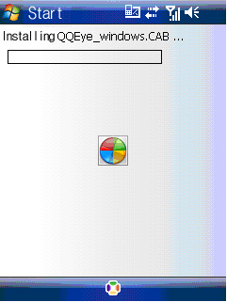

4）After installed, click the QQeye icon to run the program.
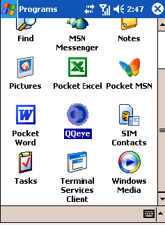

5）login the main interface as follow.
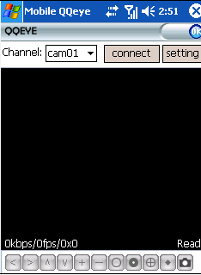
Channel: select the channel you want to monitor. When you select a channel, it will connect to DVR automatically.
Connect: press it to connect to DVR.
Setup: Press it to enter into the interface to config the parameters for mobile phone monitor.
Button definition：【PTZ direction control（left、right、up、down）】;【area select（zoom in、zoom out）】;【focus（＋、－）】;【aperture（＋、－）】;【snapshot】.

Remark: Please make sure the parameters for PTZ in DVR is correct.
Snapshot default save path is: Program>>>QQeye>>>> photo

6）When you login for the first time, please setup the network parameters first, press setup to enter into the interface, as follow:
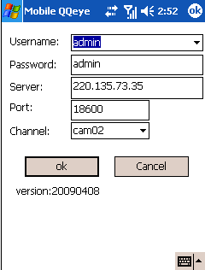

User name: can be blank.
Password: should be the same as IE.
Sever: the public IP or dynamic domain name of DVR.
Sever port: this port is the mobile port you setup in DVR.
Channel: setup the default channel you want to check.
Please press OK after you finished setup.
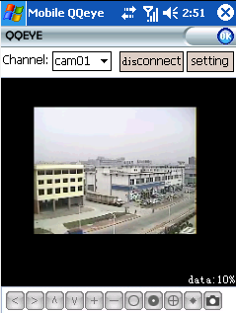
7）Display mode
Normal/Full screen
Remark: Click screen can switch the display mode between normal and full screen.

2.2 Symbian Operating system

1）Please copy the install program whose name is amplayersetup.CAB from the attached CD to your mobile phone, the default save path is memory card. As follow:
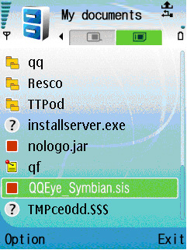

2）Click the program to install it.
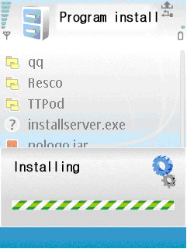

3）You can select the install path you want as the follow picture .
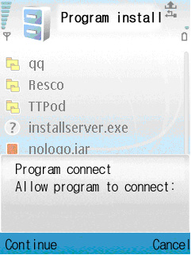

4）Please select continue when you got the follow window, and make sure your mobile phone can access to internet.
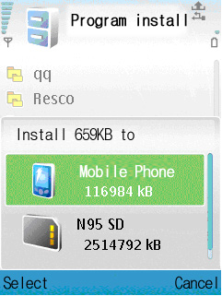

5）you will got a message “install finished” after installed successful.
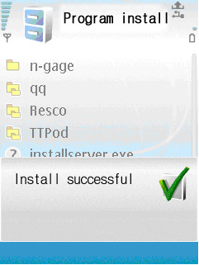

6）Please find the QQeye icon in Application and run it.
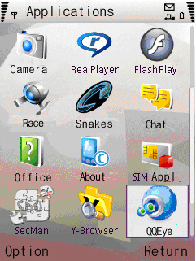

7）when you login, you will find the window as follow:
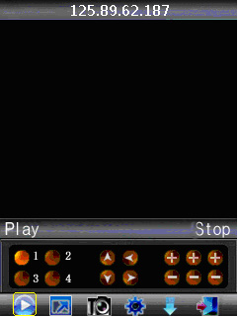
Button definition：
CH1 ~ CH2 PTZ ： up left zoom in + focus + aperture +
CH3 CH4 PTZ ：down right zoom out – focus – aperture –
【Play/Pause】 【Full screen/Normal】 【Snapshot】 【Setting】 【Next group】【Exit】

Remark: Snapshot default save path is: "C：\Data\Images\”

8）When you login for the first time, please setup the network parameters first, press 【Setting】 to enter into the interface, as follow:

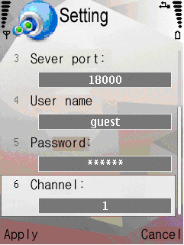

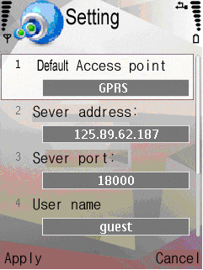

Default Access point: Please select the network, GPRS/EDGE/3G
Sever address: the public IP or dynamic domain name of DVR.
Sever port: the sever port is the mobile port you setup in DVR.
User name: can be blank.
Password: the same as IE.
Channel: setup the default channel you want to check.
Please press Apply after you finished setup.

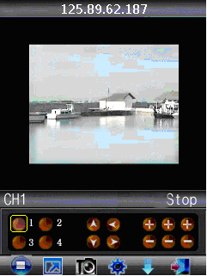

9）Display mode
Normal/ Full screen

Remark: Click screen can switch the display mode between normal and full screen.

10）Next Group
Click the button can switch the camera display group .cam1~cam4, cam5~cam8, cam9~cam12, cam13~cam16.For variety channels DVR

